Experiment 10: function
Create a function to find the factorial of a number and display the result

set serveroutput on;
show serveroutput;
CREATE OR REPLACE FUNCTION factorial(n INT)
RETURN INT IS
fact INT := 1;
BEGIN
FOR i IN 1..n LOOP
fact := fact * i;
END LOOP;
RETURN fact;
END;
/
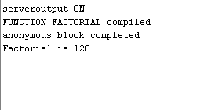
CREATE TABLE customers_seca_s2 (
cust_id NUMBER,
cust_name VARCHAR2(50)
);
INSERT INTO customers_seca_s2 VALUES (1, 'A');
INSERT INTO customers_seca_s2 VALUES (2, 'B');
COMMIT;
CREATE OR REPLACE FUNCTION total_customers
RETURN NUMBER IS
total NUMBER := 0;
BEGIN
SELECT COUNT(*) INTO total FROM customers_seca_s2;
RETURN total;
END;
/
DECLARE
num NUMBER;
BEGIN
num := total_customers;
DBMS_OUTPUT.PUT_LINE('Total number of customers = ' || num);
END;
/
